
Islamic University of Technology

Project Title: RLC Circuit Analyzer
Name : Redwan Nabil
Student ID : 220021146
Section : A
Department : EEE
Course No : EEE- 4416
Date of Submission : 30. 09. 2025

1. Introduction
This project is a custom-built MATLAB App that functions as an RLC Circuit Analyzer. The user interface is cleanly divided into input, output, and visualization areas. On the left, it features five clearly labeled edit fields for users to input the circuit's Resistance (R), Inductance (L), Capacitance (C), Peak Voltage (V), and Frequency (f).
After entering the parameters, a user can press the red "Calculate & Plot" button. The application then processes these inputs to compute the circuit's total Impedance (Z), Peak Current (I), and Phase Angle (φ), displaying these results in the fields below the inputs. Simultaneously, the app generates a graphical representation on the right, plotting the Voltage and Current Waveforms over time to provide an immediate visual analysis of the circuit's behavior.

2. How to Use the Application
- Launch the App: Run the application in MATLAB to open the main window, which is titled "MATLAB App".
- Enter Parameters: In the panel on the left, type the circuit values into the five edit fields. For example, enter 10 ohm for Resistance, 0.02 Henry for Inductance, 0.0001 Farad for Capacitance, 100 v for Peak Voltage, 50Hz for Frequency.
- Calculate Results: Click the red "Calculate & Plot" button.
- View Outputs: The calculated results will instantly appear in the output section on the lower left, showing the values for Impedance (Z), Peak Current (I), and Phase Angle (φ).
- Analyze the Plot: Observe the graph on the right, which will display the final Voltage (V) waveform as a solid blue line and the Current (A) waveform as a dashed red line, complete with a legend for clarity.

3. Screenshots:
- Design View:
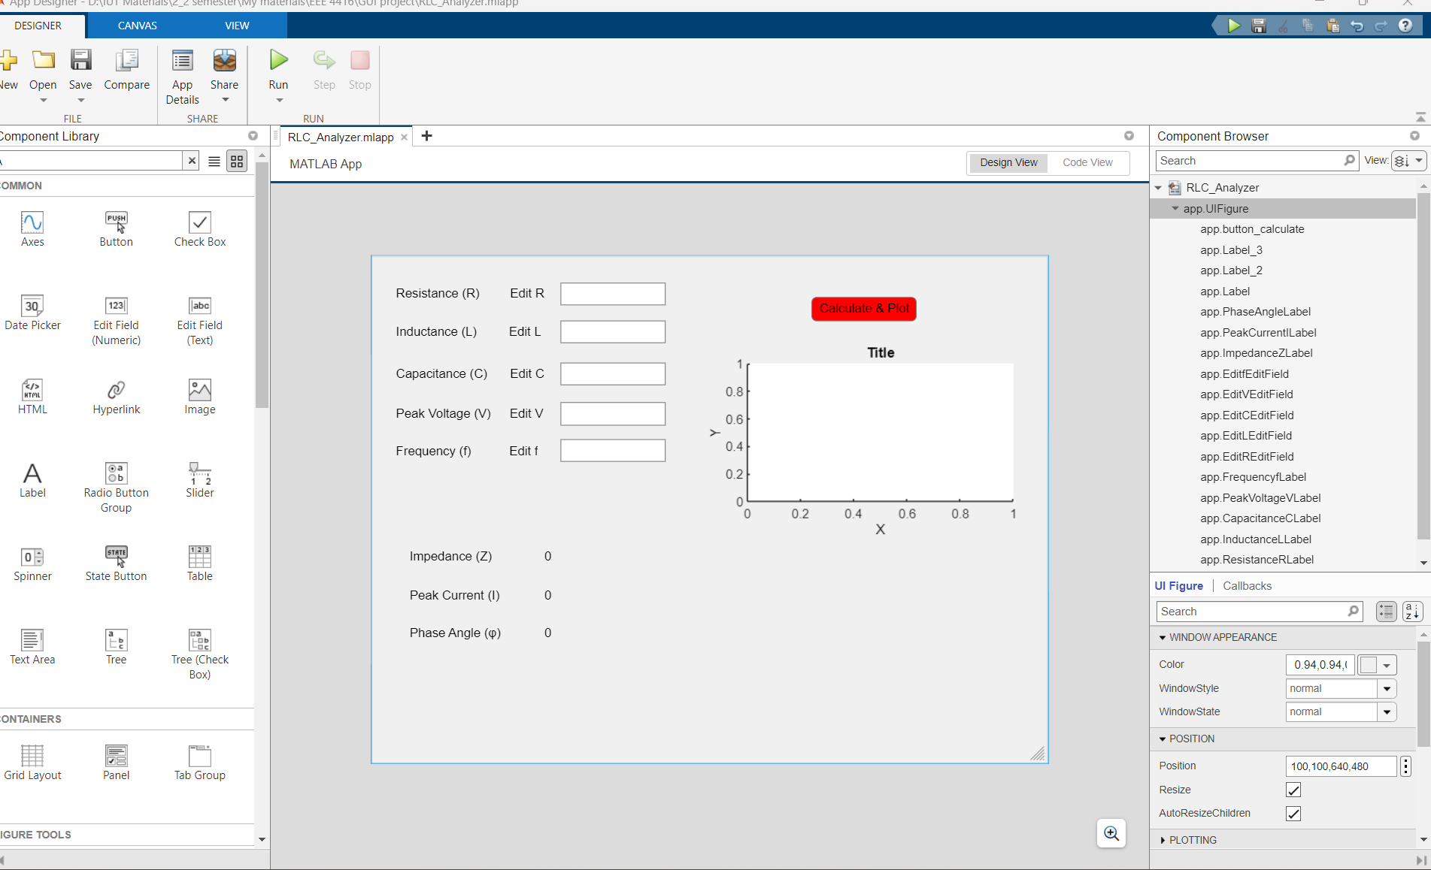
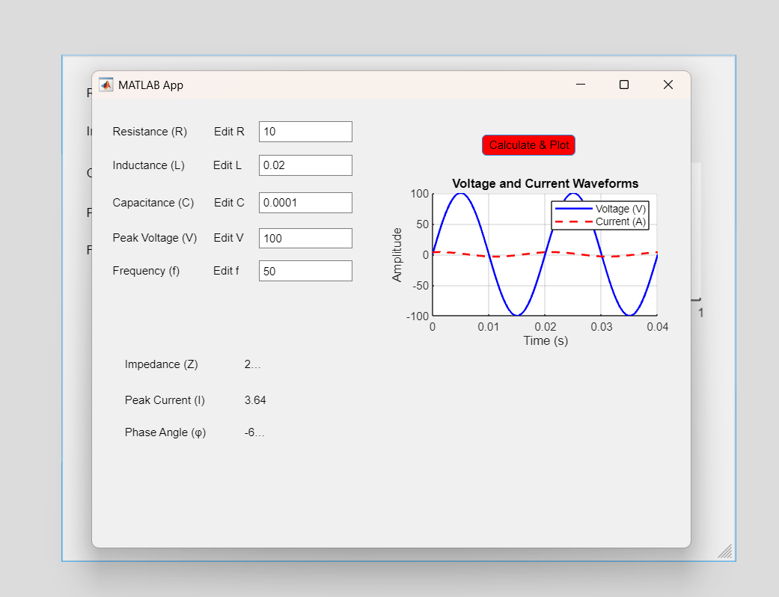
4. Discussion:
The development of this RLC Circuit Analyzer in MATLAB App Designer proved to be an effective exercise in creating a practical engineering tool. The application successfully translates theoretical circuit equations into an interactive and visual format, which offers significant advantages over manual, static calculations.
A key outcome of this project is the ability to instantly visualize the phase relationship between voltage and current. For instance, using the sample data, the negative phase angle (-6.2 degrees in the screenshot) correctly indicates a predominantly capacitive circuit, where the current leads the voltage. This is clearly represented on the plot, where the peak of the current waveform occurs before the peak of thevoltage waveform. This immediate graphical feedback is invaluable for students and engineers to build an intuitive understanding of AC circuit theory, which can often be abstract when limited to textbook formulas.
However, the project has several limitations. The current implementation is restricted to analyzing only series RLC circuits and cannot handle parallel or more complex series-parallel configurations. Furthermore, it assumes ideal components and does not account for factors like inductor resistance or capacitor leakage, which would be present in a real-world circuit.
For future development, this application could be significantly enhanced. A primary improvement would be to add functionality to select between series and parallel circuit configurations. Another powerful feature would be to implement a frequency sweep analysis, allowing the user to plot impedance versus frequency to visually identify the circuit's resonant frequency. Finally, adding calculations and plots for different types of power (real, reactive, and apparent) would make the tool even more comprehensive for circuit analysis.

